Case Study: Pharmaceutical Sales & Market Analysis

Tools Used: SQL (MySQL), Power BI, Excel
This case study demonstrates an end-to-end data analysis workflow using pharmaceutical sales data to uncover revenue drivers, product performance trends, and regional market opportunities.

1. Business Task
A pharmaceutical company aims to improve revenue performance and market competitiveness by understanding sales trends, product performance, and regional demand patterns.
This analysis focuses on identifying key revenue drivers, top-performing medicines, and geographic opportunities using historical pharmaceutical sales data.
The insights generated will support strategic decisions related to product optimization, inventory management, and market expansion.
Key Metrics
- Total Revenue: $4.19B
- Top Products: Paracetamol, Azithromycin
- Revenue Trend: Peak → Decline → Stabilization
- Regional Distribution: Even across markets

2. Key Business Question
The primary question guiding this analysis is:
What factors drive pharmaceutical sales performance across products, regions, and time?

3. Stakeholders
- Pharmaceutical sales and marketing team (responsible for sales strategy)
- Supply chain and inventory management team
- Executive leadership (decision-makers for expansion and investment)

4. Context of Additional Questions
Additional business questions include:
- Which medicines generate the highest revenue?
- Which regions show the strongest and weakest performance?
- Are there seasonal trends in pharmaceutical sales?
- How did external factors such as COVID-19 impact sales?
- Are there inventory risks related to stock levels or product expiry?

These questions support deeper analysis while maintaining focus on identifying key revenue drivers and market opportunities.

5. Data Source and Preparation
The dataset used for this analysis is the:
Global Pharmacy Sales Dataset (2020–2025) sourced from Kaggle.
The dataset contains daily pharmaceutical sales records across multiple regions and countries, including product-level, geographic, and inventory-related information.

5.1 Dataset Features
The dataset includes the following key fields:
- Date Information: date, year, month, day
- Geographic Data: region, country
- Product Details: medicine, category
- Customer Segment: age_group
- Sales Metrics: units_sold, unit_price
- Inventory Data: stock_level, expiry_days_remaining
- External Factor: covid_flag

5.2 Data Ingestion
The dataset was downloaded in CSV format and loaded into Excel for initial data exploration and preprocessing.

6. Data Processing

6.1 Data Cleaning
To ensure data quality and consistency:
- Checked for missing or null values across all columns
- Verified that all key fields (medicine, region, units_sold, unit_price) contained valid values
- No missing or inconsistent records were identified

6.2 Data Type Validation
- Ensured that the date column was in proper date format
- Verified numeric columns such as:
  - units_sold
  - unit_price
  - stock_level

6.3 Feature Engineering
New variables were created to support analysis:
- Revenue
Calculated as:
=units_sold * unit_price
This metric represents total sales value per transaction and serves as the primary KPI for analysis.
- Month Name
Extracted from the date column:
=TEXT(date,"MMM")
This improves readability in visualizations (e.g., Jan, Feb, Mar).
- Year-Month
Created for time-series analysis:
=TEXT(date,"YYYY-MM")
This enables tracking of monthly trends and performance over time.

6.4 Data Quality Summary
- The dataset was found to be clean and well-structured
- No missing values detected
- Additional features successfully created for analysis
- The data is ready for SQL-based analysis and visualization

6.5 Analysis Approach
The analysis will be conducted using SQL to aggregate and transform the data, focusing on key metrics such as revenue, product performance, and regional trends.
The processed data will then be visualized using Microsoft Power BI to create interactive dashboards and uncover insights.

7. Data Analysis (SQL)
The dataset was analyzed using SQL in MySQL to extract insights related to revenue performance, product trends, regional distribution, and external factors such as COVID-19.
7.1 Total Revenue Analysis
SELECT SUM(revenue) AS total_revenue
FROM pharma_sales;
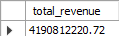

Insight
The total revenue generated across the dataset is approximately 4.19 billion, indicating a large-scale pharmaceutical market.
This highlights the overall business size and provides a baseline for further analysis.
7.2 Top Performing Medicines
SELECT medicine,
SUM(revenue) AS total_revenue
FROM pharma_sales
GROUP BY medicine
ORDER BY total_revenue DESC
LIMIT 10;
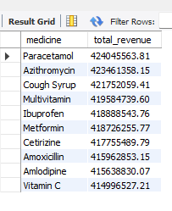

Insight
- Top medicines include:
- Paracetamol (~424M revenue)
- Azithromycin (~423M revenue)
- Cough Syrup (~422M revenue)
- Revenue across top medicines is closely distributed (~414M–424M)
This demonstrates:
- A well-diversified product portfolio
- No reliance on a single product for revenue generation

7.3 Revenue by Region
SELECT region,
SUM(revenue) AS total_revenue
FROM pharma_sales
GROUP BY region
ORDER BY total_revenue DESC;
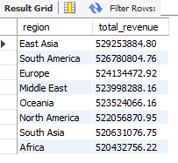

Insight
- Revenue is evenly distributed across all regions (~520M–530M)
- No region significantly dominates
This demonstrates:
- A strong global market presence
- Low geographic dependency risk
7.4 Monthly Revenue Trends
SELECT year_month_key,
SUM(revenue) AS monthly_revenue
FROM pharma_sales
GROUP BY year_month_key
ORDER BY year_month_key;
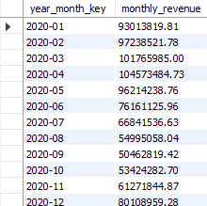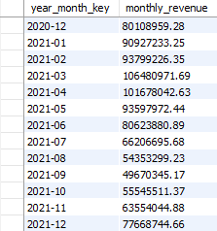
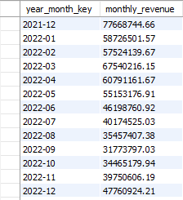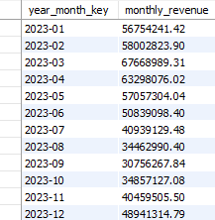
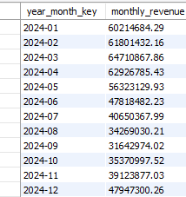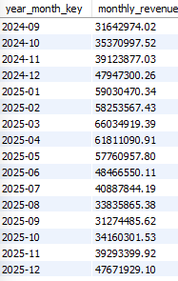

Insight
- Revenue peaked during early periods (2020–2021), reaching levels above 100M.
- This was followed by a significant decline through 2022, dropping to approximately 30M–40M.
- In later periods, revenue stabilized in the range of 40M–60M.
This reflects:
- Transition from high-demand phase (possibly pandemic-driven)
- To a stable market condition
7.5 Category Performance
SELECT category,
SUM(revenue) AS total_revenue
FROM pharma_sales
GROUP BY category
ORDER BY total_revenue DESC;
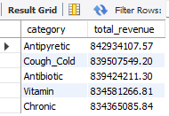

Insight
- Categories such as Antipyretic, Antibiotic, and Cough & Cold contribute the highest revenue
- However, all categories show similar revenue contribution (~834M–842M)
This demonstrates:
- A balanced product mix
- Coverage across both acute and chronic treatments
7.6 COVID Impact Analysis
SELECT covid_flag,
SUM(revenue) AS total_revenue
FROM pharma_sales
GROUP BY covid_flag;
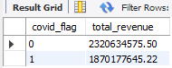

Insight
- COVID period showed reduced overall revenue (~1.87B vs ~2.32B), indicating supply chain disruptions and shifting demand patterns.
This indicates:
- Overall sales were lower during COVID
- Possible contributing factors include:
- Shift toward specific treatments
- Supply chain disruptions
- Reduced general demand

8. Key Findings
- The pharmaceutical market generated over $4.19B in revenue, indicating large-scale operations
- Revenue is evenly distributed across medicines, regions, and categories, showing strong diversification
- No single product, region, or category dominates, reducing business risk
- Revenue trends show a decline following early peaks, followed by stabilization
- The COVID period showed lower overall revenue, suggesting market disruption rather than growth

9. Data Visualization (Power BI)
The analyzed data was visualized using Microsoft Power BI to create an interactive dashboard that enables dynamic exploration of pharmaceutical sales performance.
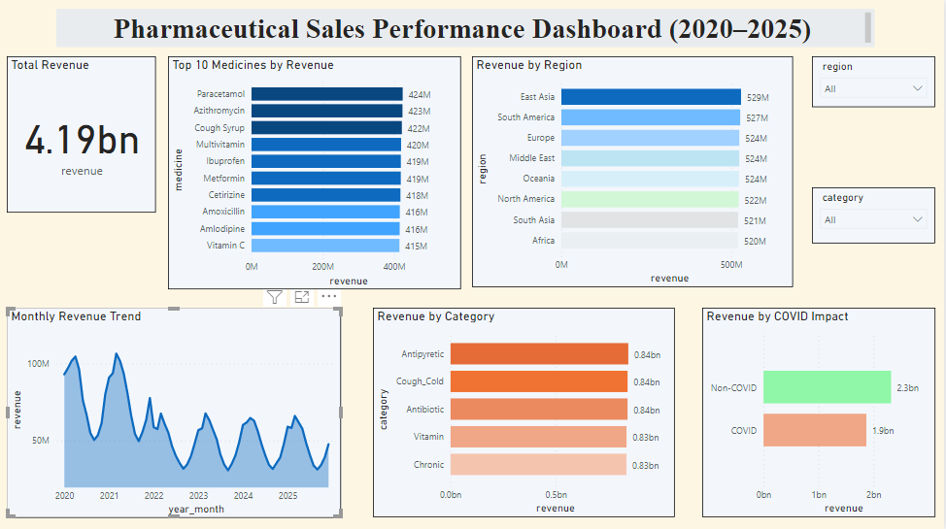

Dashboard Features
The dashboard includes the following key visuals:
- Total Revenue KPI
Displays total revenue of approximately $4.19 billion, providing a high-level overview of business performance.

- Top 10 Medicines by Revenue
A bar chart highlights the highest revenue-generating medicines such as Paracetamol, Azithromycin, and Cough Syrup.
This visualization highlights key revenue-driving products.
- Revenue by Region
A bar chart comparing revenue across regions.
The chart confirms that revenue distribution is balanced globally, with no dominant region.
- Monthly Revenue Trend
A time-series (area chart) showing revenue trends over time.
Key observations include:
  - Peak revenue during early periods (2020–2021)
  - Decline during 2022
  - Stabilization in later years

- Revenue by Category

A bar chart showing revenue contribution by product category.

The visualization confirms a balanced contribution across categories such as:
- Antipyretic
- Antibiotic
- Cough & Cold
- Vitamin
- Chronic

- Revenue by COVID Impact

A comparison of revenue during and outside COVID periods.

The chart shows lower revenue during COVID period, highlighting market disruption.

- Interactive Filters (Slicers)

The dashboard includes slicers for:
- Region
- Category
These allow users to dynamically filter and explore the data.

10. Conclusion
This analysis provides a comprehensive view of pharmaceutical sales performance across products, regions, and time.
Key conclusions include:
- The business operates at a large scale, generating over $4 billion in revenue
- Revenue distribution is balanced across medicines, regions, and categories, reducing dependency risk
- Sales trends show a transition from high demand during early years to a more stable market
- COVID-19 had a negative impact on overall sales performance
- The product portfolio is well-diversified, supporting consistent revenue generation
Overall, the analysis demonstrates strong market presence and stability, while highlighting opportunities for strategic optimization.

11. Recommendations

Based on the analysis, the following recommendations can be made:
- Focus on optimizing top-performing medicines to drive further revenue growth
- Maintain diversified product portfolio to minimize risk
- Monitor regional performance to support targeted marketing and expansion strategies
- Improve supply chain resilience to mitigate external disruptions such as pandemics
- Leverage time-series insights for demand forecasting and inventory planning

